**Capabilities covered:**

* Understand the web standards, patterns & protocols
* Define client & server architecture
* Implement Web UI that meets the functional specifications
* Add actions, interactions, business logic using JavaScript (ES6 & TS)
* Use Spring MVC framework to implement presentation layer of an application
* Use Spring Security framework to set up basic security controls for an application - including authentication, authorization, and data transport security (SSL)
* Use Hibernate framework to implement persistence layer of an application
* Analyse complex business scenarios and create a data model
* Use MySQL to build SQL engine for an application
* Use Java to implement business layer of your application
* Use Eclipse IDE for programming Java application
* Test, and Debug your application to make application ready for deployment
* Follow coding standard and maintain high quality by analysing various reports generated through code quality tools
* Automate the build using Maven

**Note:**

1. Do not change the table structures.
2. **READ THE QUESTION PAPER COMPLETELY BEFORE YOU START CODING.**
3. Use appropriate data types and precisions for the variables
4. Handle all exception and alternate flows
5. Use generics wherever applicable for parameters and return type
6. Write at least three test cases (both positive and negative/exceptional) for service class
7. **Loose coupling:** Create a separate Dao interfaces and implementation classes. Database interaction code should be only in DAO classes. Dao classes should not have UI code.

# **Problem statement: DTH Channel subscriptions**

Create a web application to manage information about Direct to Home subscribers. The application should allow users to subscribe for channels of his/her choice **(one customer can subscribe for many channels).** Also the subscriber should be able to view the channels he/she has subscribed for and the total subscription cost for the channels selected.

Pre-condition for the application is that the following tables should be created:

* CUSTOMER table with columns (SUBSCRIBER_ID, REGISTERED_MOBILE, FIRST_NAME, LAST_NAME)
* CHANNELS with columns (CHANNEL_ID, CHANNEL_NAME, COST_PER_MONTH)

SAMPLE DATA is shown below:

**CUSTOMERS:**

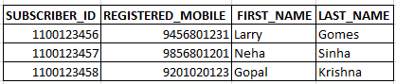

**Note:** Create a Stored Procedure to insert records into **‘CUSTOMERS’** table. [Provide database scripts file for creating stored procedure and inserting records].

**CHANNELS:**

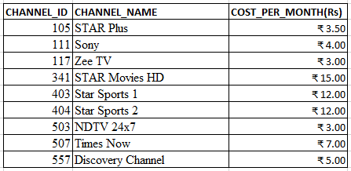

**Note:** Create a Stored Procedure to insert records into **‘CHANNELS’** table. [Provide database scripts file for creating stored procedure and inserting records].

Provide all the DDL and DML database scripts used for creating tables and records inserted. Insert at least 3 CUSTOMERS and 5 CHANNELS. Note that SUBSCRIPTION_ID is 10 digits and CHANNEL_ID is 3 digit

**Home page contains two hyperlinks**

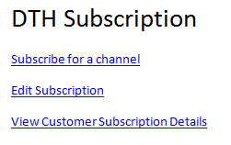

**Things to implement:**

## **Screen 1:**

**Subscribe for channel.**

On clicking “subscribe for channel” hyperlink on home page, user is redirected to Subscription Form as shown below.

**Note:** Channels drop-down should be dynamic and should be fetched from data present in the database.

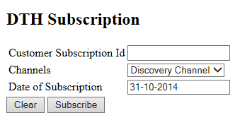

User should enter “Subscription ID” and select “channel” from drop-down and submits the form by clicking on “Subscribe”.

On successful submit Subscription details should be added in the new database table **(Subscription_Channel)** as shown below.

**The column ‘Id’ must be auto generated.**

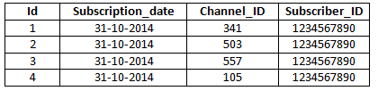

User should be redirected back to home page with message “Channel subscription done successfully”.

Clicking on “Clear” button the operation has to be aborted and user should be redirected to home page.

Following validation has to be done:

1. All fields are mandatory.
2. User should select Channel. Default option “-SELECT-“should not be submitted.
3. Date should be a valid date

## **Screen 2**

**Edit Subscription**

On clicking “Edit subscription” hyperlink on home page, user is redirected to edit form as shown below.

**Note:** Channels drop-down should be dynamic and should be fetched from data present in the database.

## 

User should enter “Subscription ID” and select “channel” from drop-down and submits the form by clicking on “Unsubscribe”.

On successful submit of details should be removed from **Subscription_Channel** table

## **Screen 3**

**Customer Subscription details**

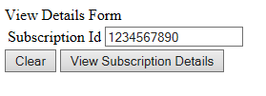

Once User enters “SUBSCRIPTION ID” and on clicking “View Subscription Details” details has to be listed as shown below (Use Ajax feature to implement this requriement). The information contains all the channels the customer has subscribed for, cost per month of each channel, total cost of subscription (Rs.100 for set top box + sum(cost of all channels) customer has subscribed for, Customer name)

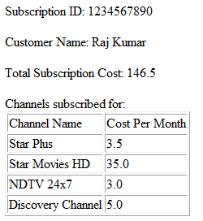

**Note:** The above report displayed should also be saved into a file for future reference

**XXXXXXXXXXXXXXXXXXXXXX END XXXXXXXXXXXXXXXXXXXXXXXXX**